6.4 SQL Case Statements

1.Using the Production.Product table, create a new column in your query called "MarginType" using the standard cost column.  If the standard cost for that product is 0, then label that as pure margin.  Otherwise, the value should be named as normal margin.

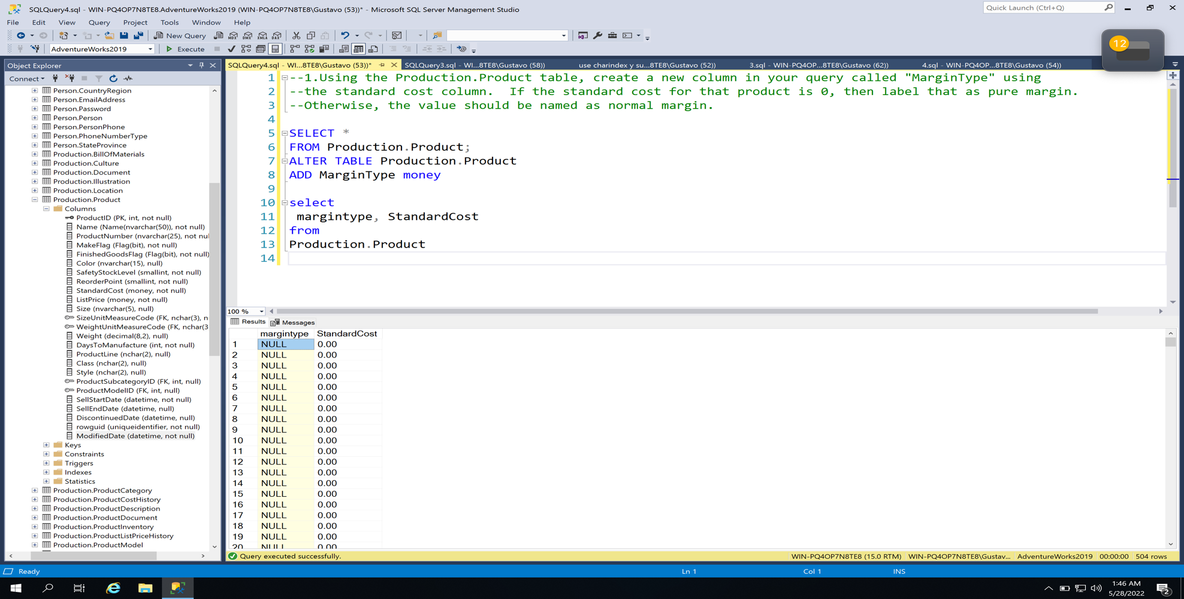

3.Using the SalesOrderDetail table, find the 4 middle characters in the carrier Tracking number(carrier tracking numbers have 3 parts).  If the carrier tracking number is null, then it should say "No Number"

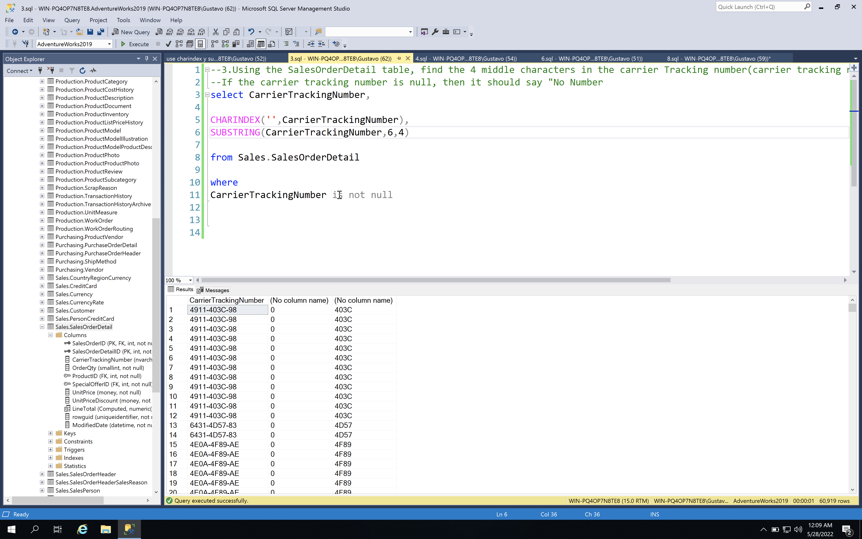

4.Using the StateProvice table, remove all spaces in stateprovince table if there are any.  For extra credit, separate any names that have two or more words into two different columns, ie New Mexico -> New and Mexico.

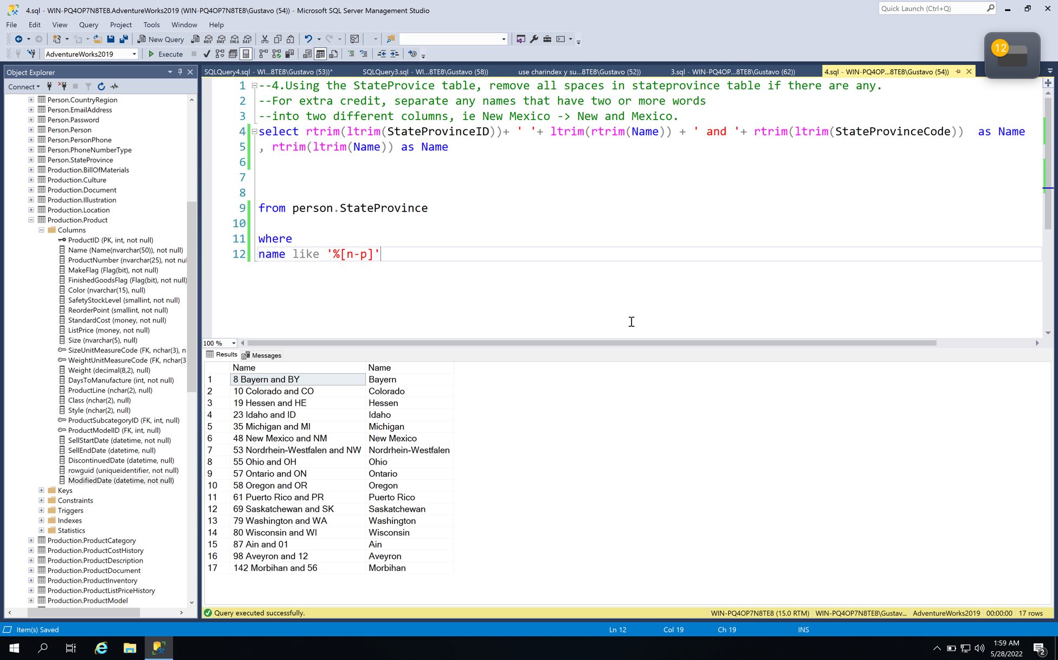

6.Find all unique last names in the person table, and convert to upper case.

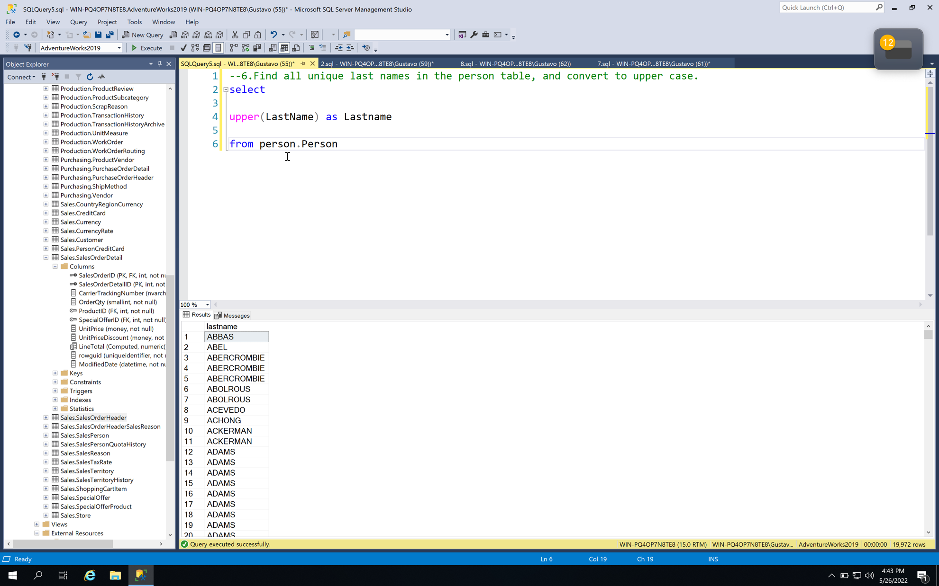

8.In the products table, if the size is above 50 then the row should say "heavy" and if it is lower or equal to 50 then it should say "light".

